Sprint 0 Design Document
Design Login Style and Team Page Layout

Login Style Wireframe and Design
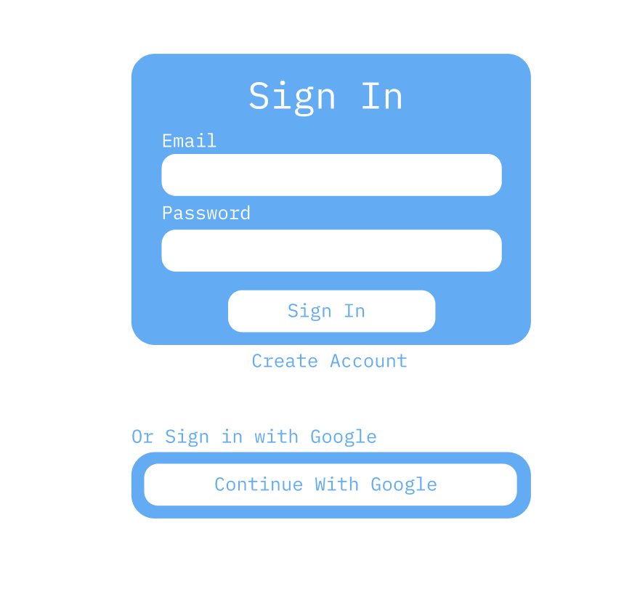
Hex Colour Coding
- #FFFFFF
- #63ABF2
Functionality
- Email and Password inputs have an outline on click
- Sign in button has a #FFFFFF outline, a #63ABF2 body and #FFFFFF text colour when hovered.
- Create Account is an html A tag
- Continue with Google button has a #63ABF2 body and #FFFFFF text colour on hover
Team Page Wireframe and Design
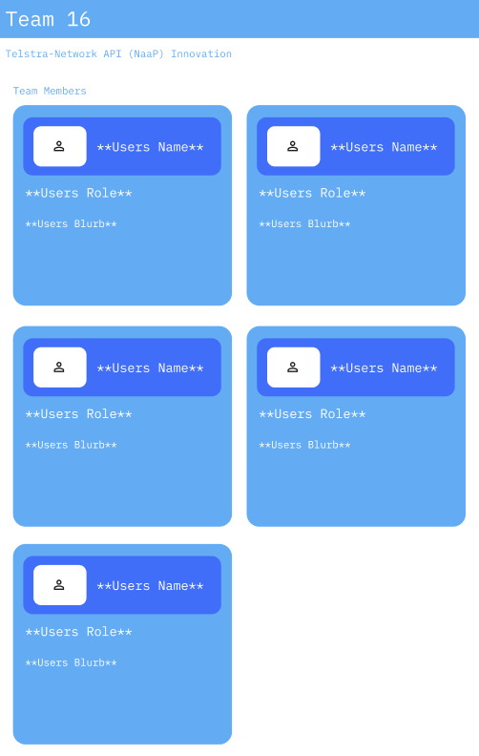
Hex Colour Coding
- #FFFFFF
- #63ABF2
- #406EF9

Functionality
- **<Name, role or blurb>** Indicates where and what team members information will be
- The team members cards are displayed in a flex box manner, according to screen width

